LAB – 4 REPORT
Name: Ozan Berk Gultegin
Submission Date:

Objective
The objective of this experiment is to analyze and enhance a speech signal contaminated with background noise using spectral processing techniques. The goal is to reduce stationary background noise while preserving speech intelligibility and quality. This is achieved through a sequence of signal processing steps including framing, windowing, spectral analysis via the Discrete Fourier Transform (DFT), noise spectrum estimation, spectral subtraction, and reconstruction using the Inverse DFT (IDFT).
The experiment also aims to evaluate the effectiveness of the enhancement through both subjective listening tests and objective signal-to-noise ratio (SNR) analysis, allowing for a comprehensive assessment of the signal quality before and after enhancement.

Graphical Results and Evaluations

II.I Signal – 1
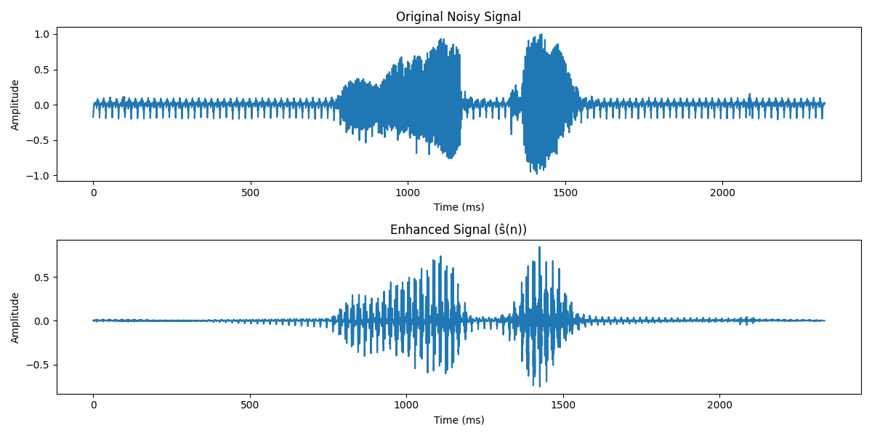
Subjective Evaluation:
The original signal contains noticeable background noise, especially before and after the speech segments. While the speech itself is generally clear and fluid, the surrounding noise negatively affects the overall listening experience. After enhancement, the background noise is significantly reduced in the non-speech portions of the signal, which results in a cleaner and more focused presentation. However, during speech, some of the background noise remains perceptible and may even appear more prominent. Additionally, the enhanced speech exhibits unnatural characteristics, such as a robotic tone and a slightly "heavier" or "slowed" quality. These artifacts may affect the naturalness of the voice but do not hinder intelligibility.

Objective Evaluation:
The signal-to-noise ratio (SNR) was calculated for both the noisy and enhanced versions of the signal. The SNR of the original (noisy) signal was 14.98 dB, whereas the enhanced signal achieved an SNR of 32.70 dB. This substantial improvement of approximately 17.72 dB confirms the effectiveness of the enhancement algorithm in reducing stationary noise. Despite some perceptual degradation in naturalness, the enhancement method successfully suppresses unwanted noise and improves the clarity and separation of speech in non-speech regions.

II.II Signal – 2
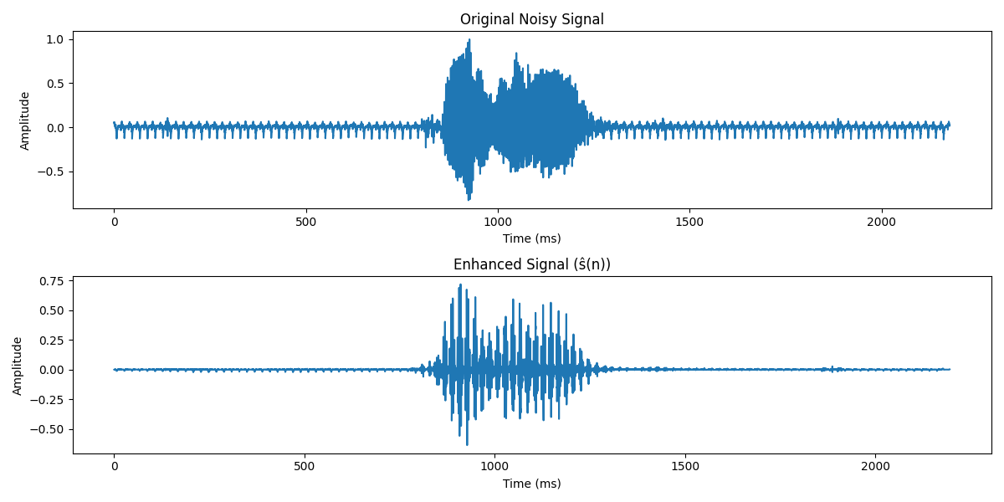
Subjective Evaluation:
In the original signal, background noise is clearly audible, especially in the non-speech segments before and after the spoken content. The speech itself is intelligible but accompanied by low-level noise. After enhancement, the background noise is reduced, though not as effectively as in Signal 1, residual noise remains noticeable in the silent parts. The speech remains understandable but has taken on a robotic quality, with a slightly unnatural tone. Despite these artifacts, the enhancement improves overall clarity by attenuating the background noise.
Objective Evaluation:
The noisy signal had an SNR of 17.24 dB, which improved to 32.13 dB after enhancement. This represents a significant improvement of approximately 14.89 dB, indicating effective noise suppression. Although the residual noise and robotic artifacts reduce perceptual naturalness, the overall signal quality benefits from the increased SNR and clearer speech presentation.

II.III Signal – 3

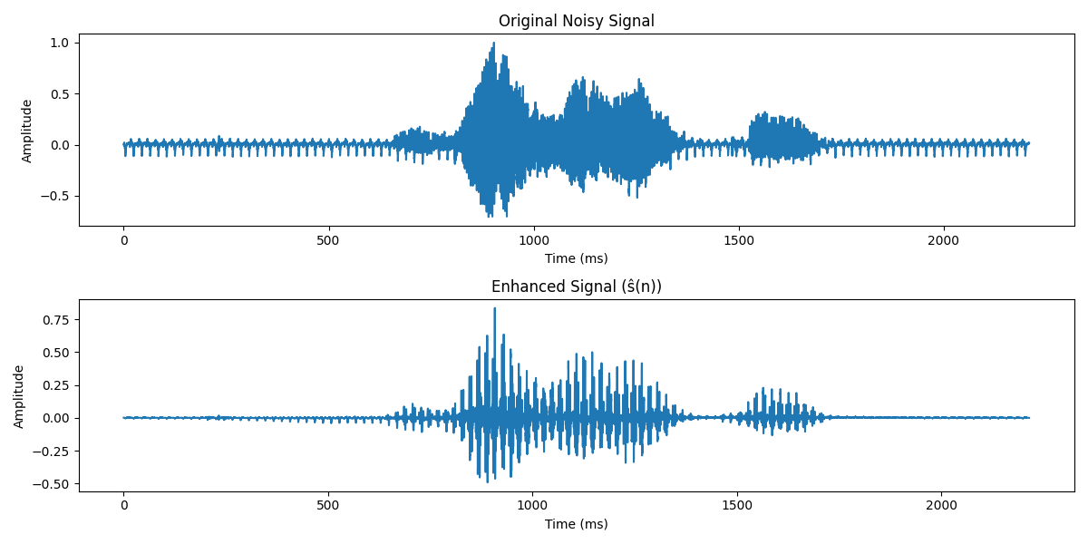
Subjective Evaluation:
In the original signal, the background noise is consistently present throughout the silent and speech segments. The speech remains understandable but is clouded by the surrounding noise. In the enhanced version, background noise is noticeably reduced at the beginning and end, though it briefly increases just before the speech begins. During the speech, a robotic and slightly "slowed" effect is perceptible. Despite these artifacts, the speech is clearer and easier to comprehend, indicating a net improvement in perceived quality.
Objective Evaluation:
The SNR improved from 17.59 dB (noisy) to 31.15 dB (enhanced), resulting in a gain of approximately 13.56 dB. This significant improvement highlights effective noise suppression. However, the presence of mild artifacts and fluctuations in background noise before speech onset slightly impacts subjective quality, even though intelligibility improves.

II.IV Signal – 4
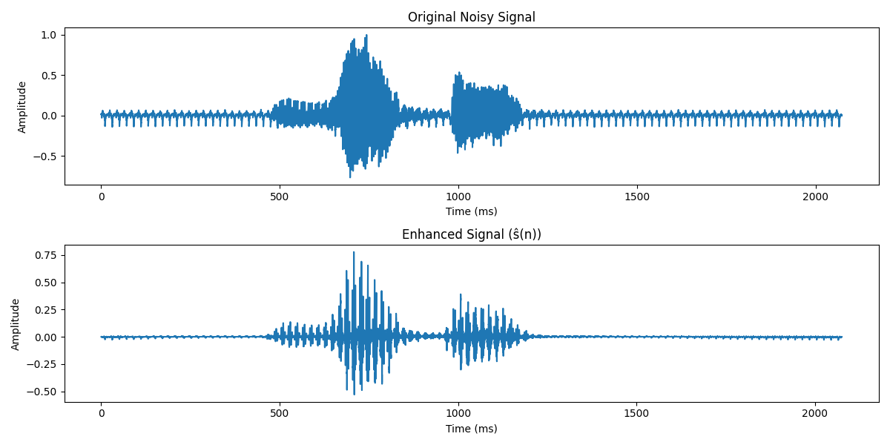
Subjective Evaluation:
The original noisy signal contains considerable background noise throughout, which masks parts of the speech. After enhancement, there is a noticeable drop in noise during the non-speech portions, particularly at the beginning and end. The speech becomes significantly more audible and prominent. However, some distortion and robotic artifacts are present, likely due to aggressive noise suppression. Despite this, the enhanced speech is much easier to understand and overall clarity is improved.

Objective Evaluation:
The SNR increased from 10.49 dB to 23.88 dB, giving a solid improvement of 13.39 dB. This indicates substantial noise suppression, consistent with the visual waveform and subjective impressions. The trade-off appears to be slight distortion in speech quality, but the intelligibility benefits outweigh the drawbacks.

II.V Signal – 5
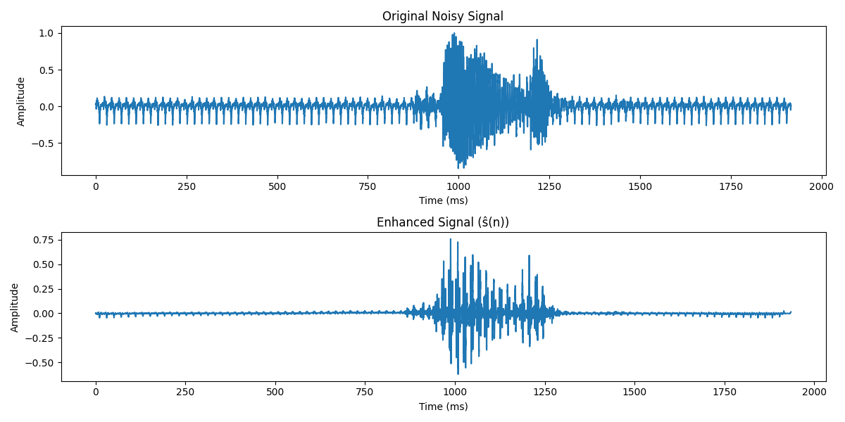
Subjective Evaluation:
The enhanced signal significantly reduces the background noise at the beginning and end, though some residual noise remains due to the high initial noise level. The speech is clearer and louder, but also noticeably more robotic compared to the other signals. Near the end of the speech (still during vocalization), background noise becomes slightly more perceptible again. Despite these artifacts, intelligibility has improved compared to the original.
Objective Evaluation:
The SNR improved from 10.78 dB to 24.12 dB, a 13.34 dB increase. This shows strong noise suppression and confirms the observed clarity improvement. However, the aggressive noise removal might be contributing to the increased robotic quality in the speech, especially noticeable toward the end of the utterance.

Summary and Conclusion
This lab work aimed to evaluate the performance of a speech enhancement algorithm using both objective and subjective criteria. The signals analyzed varied in their original noise levels and speech content, providing a diverse testbed for evaluation. From an objective perspective, all enhanced signals exhibited a substantial increase in Signal-to-Noise Ratio (SNR). The improvements ranged from approximately +13 dB to +15 dB. The highest post-enhancement SNR was 31.15 dB, achieved in a case where the original signal was already moderately clean. Subjectively, the enhanced signals showed consistent noise reduction at the beginning and end of each clip. Speech clarity was significantly improved in all cases, with intelligibility notably better than in the noisy versions.
However, some common artifacts were introduced as a result of the enhancement,
- A robotic or metallic quality was present in most enhanced signals, especially during speech segments.
- Signals with higher original noise showed more aggressive suppression, occasionally making the speech feel slightly slowed or distorted
Overall, the enhancement method succeeded in balancing noise reduction with speech preservation. While some naturalness was sacrificed the trade-off resulted in much clearer and more intelligible speech. These results suggest the approach is effective in low-SNR environments,

